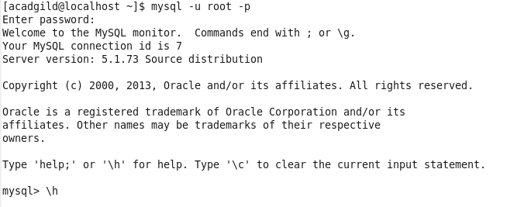

**Step1:Create a employee table in Mysql and columns as Emp_id, Emp_name, Dept_name(Hadoop Developer), Emp_sal and Inserting values into the Table Employee**

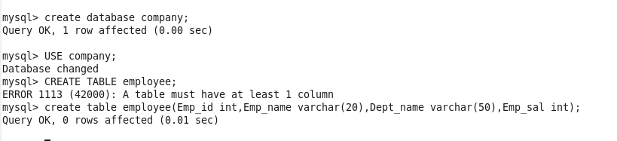

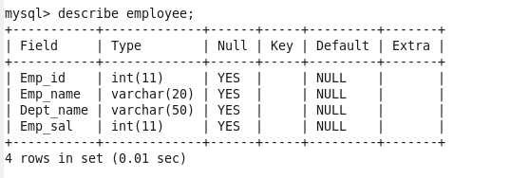

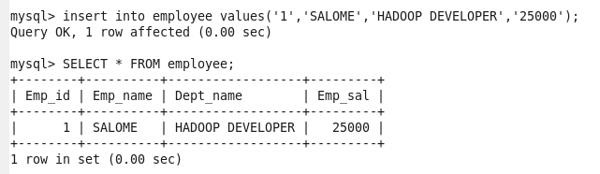

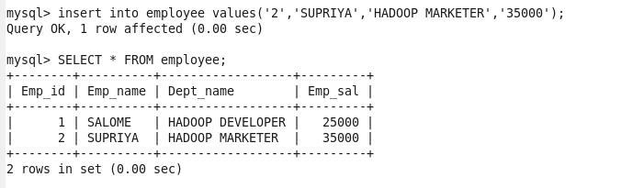

**Step2: Import the employee table contents into the HDFS directory using Sqoop.**

**COMMAND EXPLANATION**

**--connect -> It is used to give the JDBC Url of database**

**--Username🡪user name of database**

**--password🡪password of database**

**--table 🡪 give the table you want to copy from MySql**

**--target-dir🡪 directory used by Sqoop Under which the data will be stored in Hdfs**

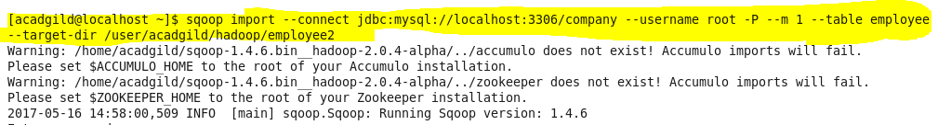

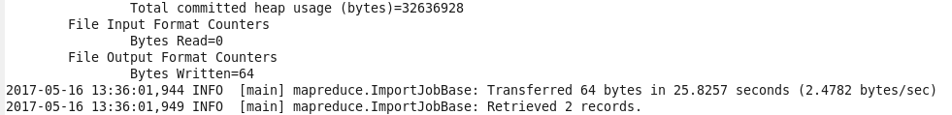

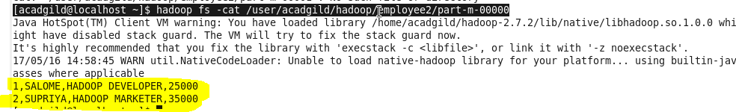

**Export employee details file from HDFS directory to Mysql table employee2 using Sqoop**

**Step4:Create a employee2 table in Mysql**

**In order to export data from HDFS I will create a Table “employee2” in MySql where the export will be done**

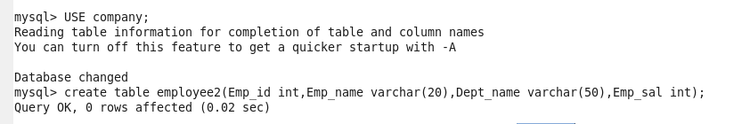

**COMMAND EXPLANATION**

**--connect -> It is used to give the JDBC Url of database**

**--Username🡪user name of database**

**--password🡪password of database**

**--table 🡪 give the table where the data will be copied in MySql from HDFS**

**--export-dir🡪 directory in Hdfs from where you want to copy to Mysql**

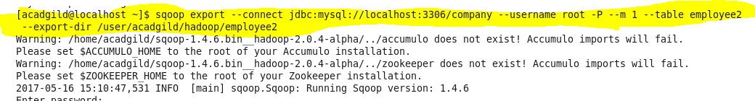

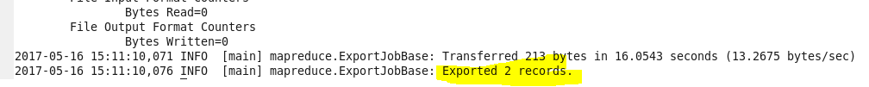

**Output**

**The data is successfully exported from HDFS to employee2 table in MySql**

